UC Merced Farmworker Health
Research Conference

UC Merced Community and Labor Center,
in partnership with California Rural Legal Assistance (CRLA) Foundation,
University of California Agriculture and Natural Resources,
and University of California Berkeley
invites you to the

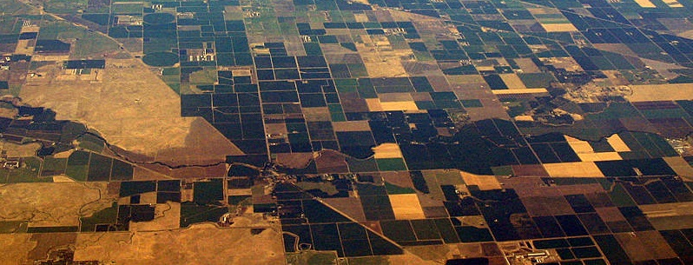

10 am to 10:30 am  Webinar #1 | Welcome: Ana Padilla, Executive Director, Community and Labor Center at UC Merced  Opening Speaker: UC Merced Chancellor Juan Sánchez Muñoz  Keynote Speaker: State Senator Anna Caballero

10:30 am to 11:30 am  Webinar #1  Moderator: Joel Diringer | Panel: Community-Based Participatory Research  - Dr. Tomas Madrigal, Communiques from the Front Line and Behind the Curtain: From Bienestar to Salud y Seguridad for Washington's Farmworkers  - Dr. Dvera Saxton, The Devil's Fruit: Farmworkers, Health, and Environmental Justice  - Dr. Bonnie Bade, Home Grown: Educating 21st Century Researchers in Collaborative Methodologies with California Farmworkers  Q&A
11:30 am to 12:30 pm  Webinar #1  Moderator:  Dr. Edward Flores  11:30 am to 12:30 pm  Webinar #2  Moderator:  Dr. Paul Brown | Panel: COVID-19 Risk Factors and Farmworker Engagement  - Dr. Ana Maria Mora, Prevalence, risk factors, and impact of SARS-CoV-2 infection among farmworkers in Monterey County, California  - Dr. Ann Cheney, Engaging Latinx Farm working Communities in COVID-19 Testing Clinics  - Dr. Alicia Riley, A demographic profile of mortality due to COVID-19 among California Farmworkers  - Mary Jo Dudley, Reaching Invisible and Unprotected Workers on Farms during the Coronavirus Pandemic  Panel: Data Collection and the COVID-19 Pandemic  - Dr. Wenson Fung, Health Access and Utilization for Agricultural Workers and Their Families  - Dr. Ester Cadavid, The Impact of Technology and Data Analytics in Respect to Outreach Efforts Within the Farmworker Community: An Organizational and Research Based Perspective  - Dianna Torres, COVID-19 Farmworker Study (Washington State)  Q&A
12:30 pm to 1:30 pm  Webinar #1  Moderator: Ignacio Santana | Panel: Heat and Wildfire  - Chelsea Langer, California Heat Illness Prevention Study (CHIPS): Main Findings and Implications  - Dr. Michael Mendez, Omar Paz, The (In)visible Victims of Wildfire Disaster: Under-standing the Vulnerability of Undocumented Latino/a and Indigenous Migrants  - Kimberly Prado, Workplace Sexual Harassment Experiences among Men and Women Farmworkers  Q&A
1:30 pm to 2:30 pm  Webinar #1  Moderator:  Dr. Sandie Ha  1:30 pm to 2:30 pm  Webinar #2  Moderator: Ellen Widess | Panel: Health and Special Topics  - Dr. Stella Beckman, Allergic and respiratory symptoms in California cannabis cultivation workers  - Leslie Olivares, Relationship between Anemia and Weight Status Among Farmworkers in California  - Dr. Paul Mills, Gene-Environment Interactions in Cancer Risk Among California Hispanic Farm Workers  - Dr. Brenda Eskenazi, COVID-19 and its impact on the health of Californian farmworkers and their families. The tale of two studies.  - Taylor Arnold, Structural Vulnerability and Occupational Injury among Latinx Child Farmworkers in North Carolina  - Chia Thao, Hmong Farmers Pesticide Narratives  - Nimrat Sandhu, Impact of the ACA on farmworker access to and utilization of healthcare services: Evidence from the NAWS  - Anuvir Singh, COVID-19 Education and Resource Development for Punjabi-speaking Farmworkers in California  Q&A
2:30 pm to 3:30 pm  Webinar #1  Moderator: Ron Strochlic | Panel: Community Interventions  - Irisela Contreras, Living with Love: Reducing Mental Health Disparities for Migrant Indigenous Communities  - Khaliah Fleming, The Development and Creation of a Culturally Tailored Cervical Cancer Educational Resource  - Dr. Leslie Cofie, Community Health Workers’ Role in Addressing Farmworker Health Disparities through Education and Information Resources  Q&A
3:30 pm  Webinar #1  3:35 pm  3:45 pm | Closing Remarks: Dr. Edward Flores, Associate Professor of Sociology, Co-Director of the Community and Labor Center at UC Merced  Closing Speaker: California State Assemblymember Robert Rivas  Adjournment

If you have any questions, please email Krystal Cortez at kcortez16@ucmerced.edu.

Special Acknowledgments
Funding and support for the conference are provided by the California Department of Public Health, and the California Endowment.

